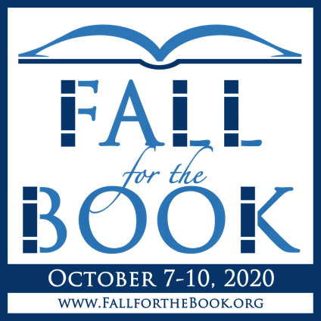
A BREAD FOR WORDS ACTIVITY
For Grades K-5

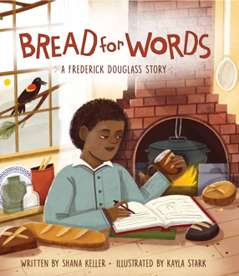

ACTIVITY #1: My Four Letters
After reading Bread for Words; a Frederick Douglass Story, use the following activities to help children understand the challenging way in which Frederick Douglass learned to read and write.

DIRECTIONS:
- Choose four letters from one of the alphabets included below. (If you do not see a language you would like to work with, feel free to find a different language online.)
- Copy one letter in each box below.
- Set a timer for one minute.
- After the timer is set, trace one letter as many times as you can for one minute or less. Repeat this step until you have traced all four letters.
- When all four letters are complete, flip your paper over (or use the printout provided), and without looking, write each letter from memory!

ACTIVITY #2: A Letter to Frederick
Writing is an important part of our lives. The story of Frederick Douglass’s path to literacy is one that many children can relate to. Encourage students to share their reactions throughout this process and why they think literacy is important.

DIRECTIONS:
- Once the first activity is completed, have students write a letter to Frederick Douglass.
- Ask them to consider their own experience copying their four letters. What other ways could they learn to read or write if they did not have a teacher to help?

Finnish (Suomi) Script
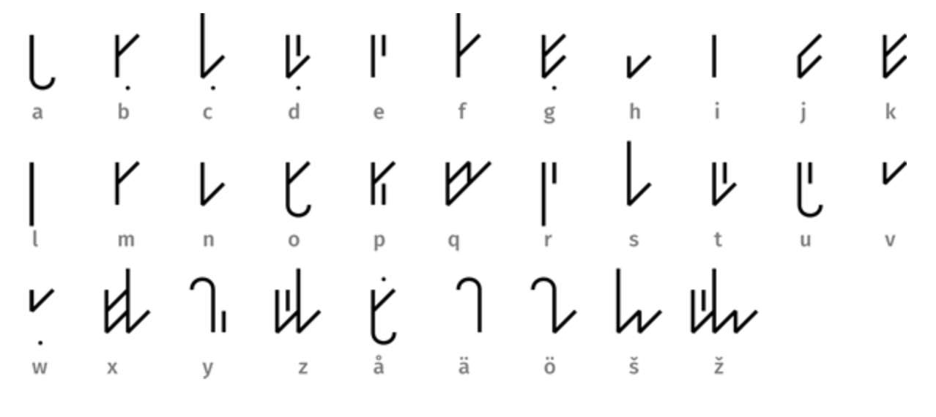
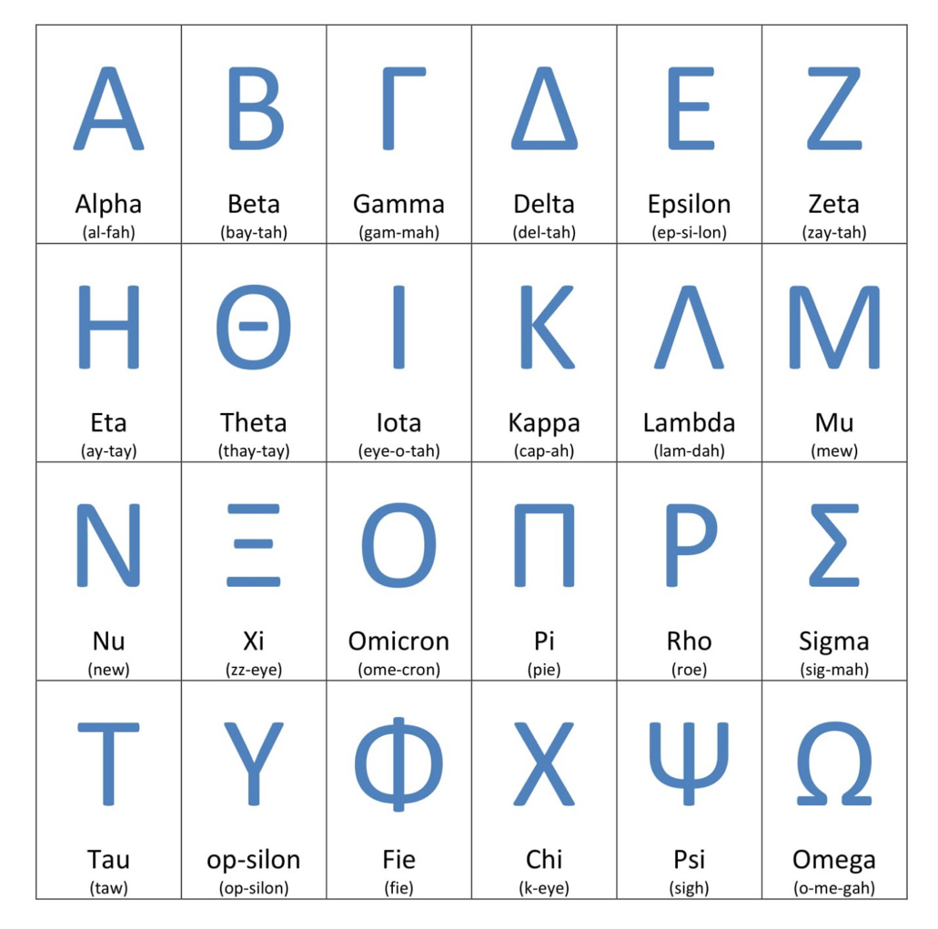
Greek
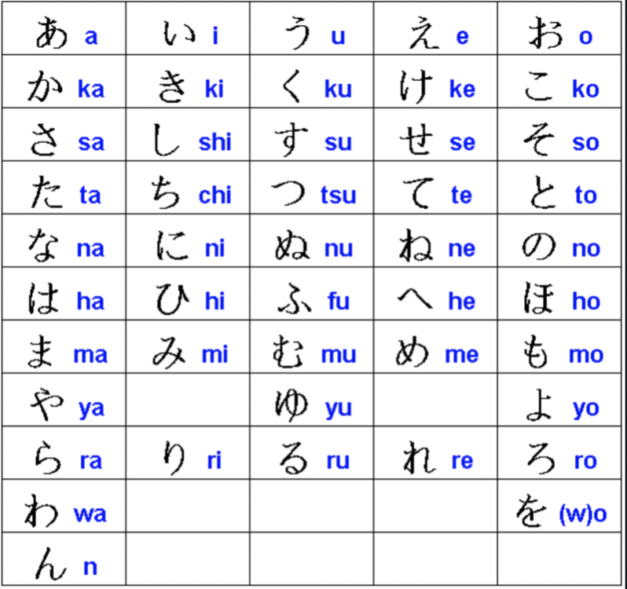
Japanese Hiragana
Cherokee
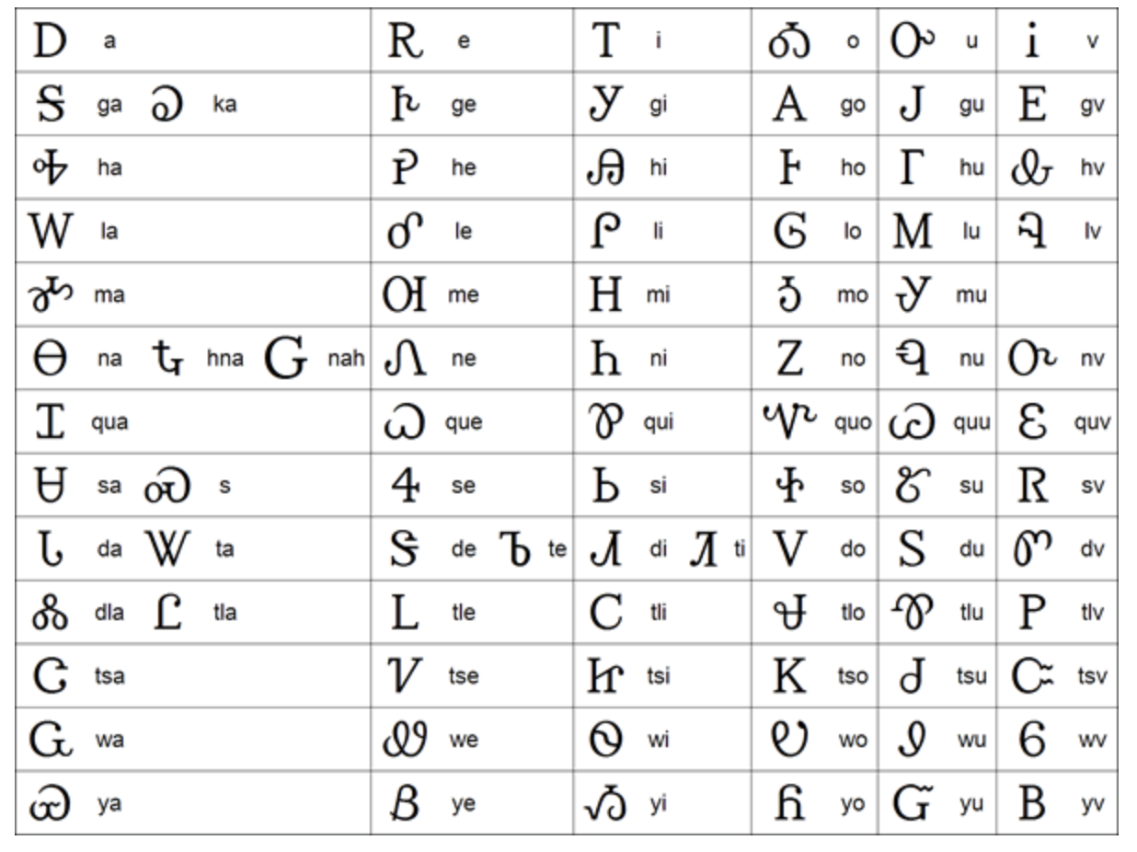
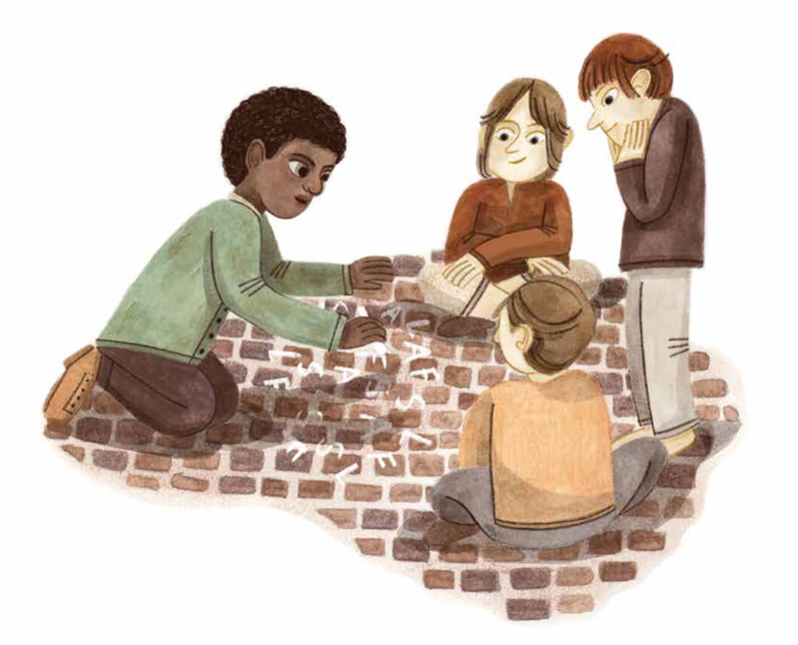
Image courtsey of Sleeping Bear Press ©
My Four Letters:

